
WATCH DOG EM

DDC & Meter
Commissioning Guide
A step-by-step field manual for Modbus RTU setup, activation and verification

THE ONE STEP YOU MUST NOT MISS
After creating each meter, open it, switch Active ON, and save. Until then the meter correctly shows Not commissioned and the software does not poll it.

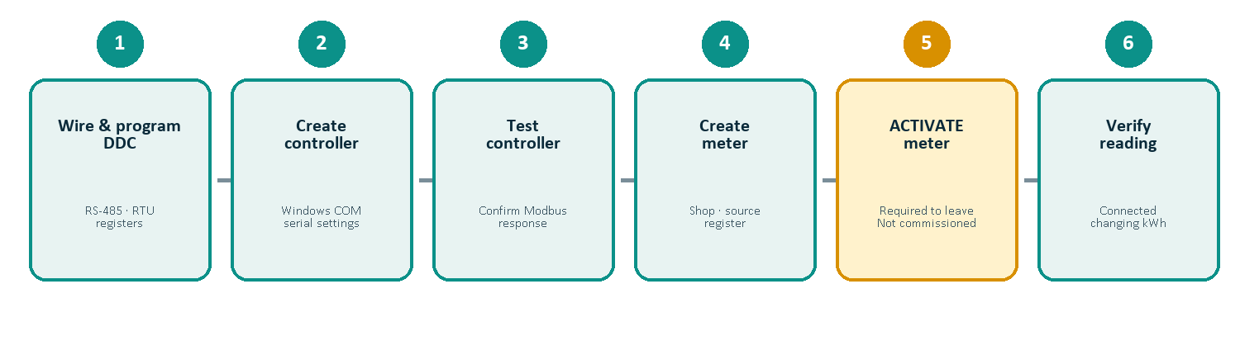
Prepared for installation and commissioning teams • Version 1.0 • September 2026

1. Before you begin
Use this order every time: prepare the RS-485 network, configure the DDC, create and test the controller, create the meter, activate it, then verify that the reading changes.
Safety
RS-485 and meter work must be performed by a qualified technician. Isolate hazardous voltages, follow the meter/DDC manufacturer instructions, and comply with local electrical rules.

Required information
Item | Record before setup
DDC | Panel name, protocol, baud, parity, data bits, stop bits, slave address
Windows PC | USB–RS-485 adapter driver and its Windows COM number
Meter | Name, serial number, shop/location, UMEME or Generator
Register | First holding register, data type, word order, stride and scale
Billing | Meter tariff, currency and effective date

Important distinction: two different port names
DDC physical port ≠ Windows COM port
The DDC may label its RS-485 connector COM2. The software must use the COM number assigned by Windows to the USB–RS-485 adapter, such as COM1, COM3 or COM5. Check Device Manager → Ports (COM & LPT).

Pre-flight checklist
• ☐ USB–RS-485 driver installed; adapter appears in Device Manager.
• ☐ No DDC programming tool or Modbus test program is holding the same COM port.
• ☐ RS-485 A/B polarity, shield/common and termination checked.
• ☐ Each DDC on the bus has a unique slave address.
• ☐ The Watch Dog EM service is running and you can sign in as Administrator.

2. Configure the RS-485 network and DDC
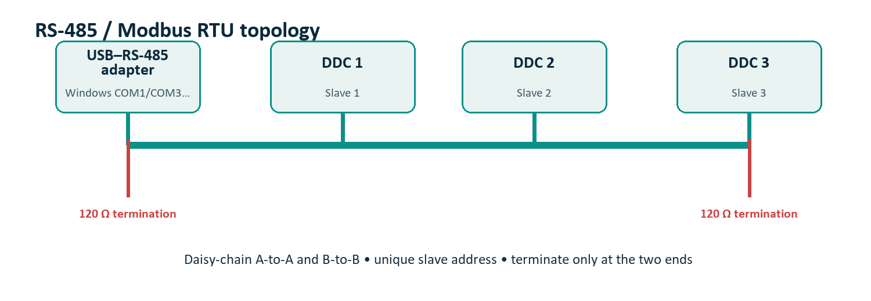

Recommended serial settings for this installation
Parameter | Value | Meaning
Protocol | Modbus RTU | Software and DDC must match exactly
Baud rate | 9600 bps | Communication speed
Data bits | 8 | Standard Modbus RTU framing
Parity | Even | Must match both ends
Stop bits | 1 | Must match both ends
Slave address | 1, 2, 3… | Unique address for each DDC on one bus

DDC sequence
1. Select the DDC RS-485 port — Use the controller manufacturer’s communication setup for its physical port, for example COM2/RS-485.
2. Set Modbus RTU — Do not mix ASCII and RTU. Save/download the settings to the DDC.
3. Set the serial frame — Use 9600, 8 data bits, Even parity and 1 stop bit unless the approved site schedule says otherwise.
4. Set the slave address — Use 1 for the first DDC, then a unique value for every additional DDC sharing the bus.
5. Publish meter values — Move each accumulated kWh value into consecutive D registers that are exposed as Modbus holding registers.

3. Build and verify the DDC register map
The application reads accumulated energy. Each software channel must point to the exact Modbus holding register published by the DDC.

Example map used in this project
Meter channel | DDC words | First Modbus register | Type | Stride | Scale
1 | D100–D101 | 4196 | UInt32 | 2 | 0.01
2 | D102–D103 | 4198 | UInt32 | 2 | 0.01
3 | D104–D105 | 4200 | UInt32 | 2 | 0.01
… | … | … | UInt32 | 2 | 0.01
45 | Confirm in DDC | Confirm in DDC | UInt32 | 2 | 0.01

Confirm before saving
4196, UInt32, stride 2, LowHigh and scale 0.01 are the project defaults—not universal Modbus rules. Verify the DDC register map. If the value is wrong but communication succeeds, test word order (LowHigh/HighLow) and scale.

Register-value check
1. Write a known test value — For example, place 123456 into the UInt32 DDC value.
2. Predict the displayed value — With scale 0.01, Watch Dog EM should show 1,234.56 kWh.
3. Change the DDC value — Increase it and confirm the displayed reading also increases after the polling interval.
4. Remove the test source — Before live billing, connect the DDC words to the real meter accumulation value.

Capacity rule
Each DDC/controller supports up to 45 meter channels. Never assign two live meters to the same register pair unless they intentionally share the same value.

4. Create the DDC/controller in Watch Dog EM
1. Sign in — Use an Administrator username and password from the normal login page.
2. Open Controller setup — Select Controller setup in the top navigation, then choose Add controller.
3. Complete the identity — Enter a clear Name and MDB panel, such as EAST-PANEL-01.
4. Enter communication — Select Modbus RTU and type the Windows COM number shown in Device Manager—not the physical DDC port label.
5. Enter serial and Modbus settings — Set 9600, Even, 8, 1 and the DDC slave address.
6. Set polling resilience — A 5-second interval, 1000 ms timeout and 2 retries are practical starting values.
7. Enable and save — Tick Enabled and the commissioning confirmation, then save with an optional note/reason if desired.

Controller configuration screen
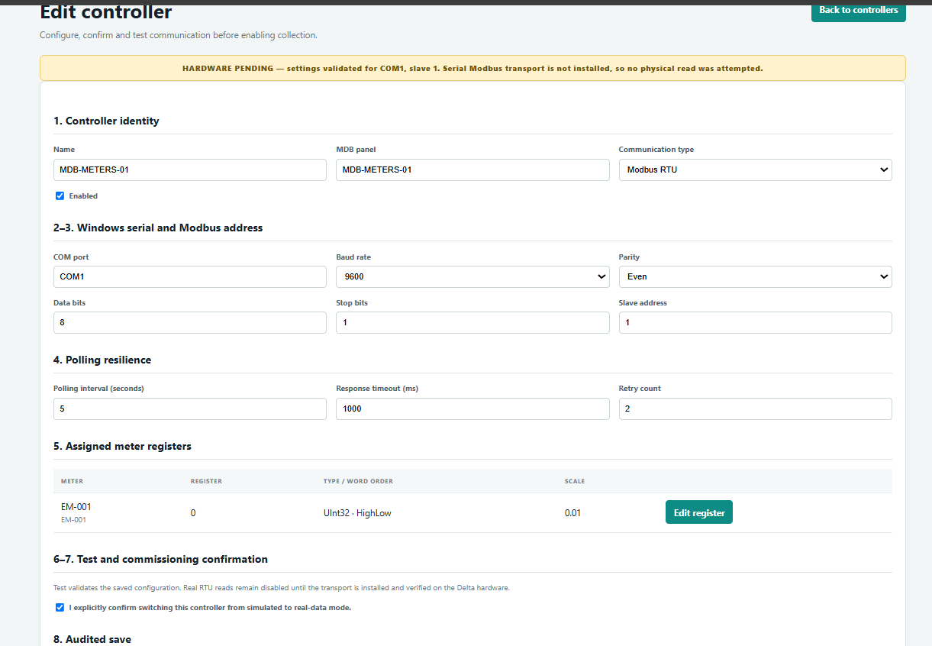
Figure 1. The screen layout may vary slightly by release. Use the current Windows COM port and approved site settings.

5. Test the controller before adding meters
From Controller setup, select Edit / test for the new controller. A successful serial test is the foundation for every meter on that DDC.

Expected result
Result | What it means | Next action
Connected / successful | A valid Modbus response was received | Continue to meter channels
Hardware pending | Serial transport or hardware access is unavailable | Check installed build, driver and COM access
Timeout / failed | No valid response | Check wiring, port, frame and slave address
Access denied / port busy | Another process owns the COM port | Close DDC software/Modbus tools; restart service

Fast diagnostic order
1. Observe TX/RX LEDs — TX flicker alone means requests are sent; RX must also respond.
2. Confirm Windows COM — Unplug/replug the adapter and see which Device Manager entry disappears/returns.
3. Swap A and B once — Only if the manufacturer labels are ambiguous and power is safely isolated.
4. Test slave address — The DDC setting and software must be identical.
5. Check serial frame — RTU, 9600, 8E1 must match exactly.
6. Use one master — Only Watch Dog EM should own the adapter during normal operation.
Do not continue blindly
If the controller test cannot get a valid response, adding 45 meter channels will not fix communication. Resolve the controller connection first.

6. Create meter channels
1. Open the controller — In Controller setup, choose the 45 channels button for the correct DDC.
2. Choose the channel count — Create only the number of meters actually connected, up to 45 per controller.
3. Set the first register — Enter the first confirmed holding register, for example 4196.
4. Set the stride — Use 2 for UInt32 because each value occupies two 16-bit registers.
5. Set format — Select UInt32, the verified word order, and the verified scaling factor.
6. Assign a shop — Select an initial shop/location if appropriate. You can adjust each meter individually afterward.
7. Generate channels — Note/reason is optional. Review the generated register matrix before editing individual meters.
Safe default behavior
Bulk-created meters are intentionally inactive. Their status remains Not commissioned until you complete and activate each meter. This prevents placeholder channels from entering live billing.

For each generated channel
• ☐ Open Edit meter.
• ☐ Replace any PENDING serial with the real meter serial number.
• ☐ Confirm controller, shop and first register.
• ☐ Select UMEME or Generator.
• ☐ Confirm UInt32, word order and scale.
• ☐ Switch Active ON and save.

7. Configure and activate each meter
Field | What to enter | Why it matters
Meter name / ID | Unique recognizable name | Used in search, dashboard and invoices
Serial number | Actual meter serial | Physical traceability
Controller | DDC carrying this reading | Selects the Modbus connection
Shop/location | Correct tenant/shop | Invoice ownership
Power source | UMEME or Generator | Places meter on the matching source page
First register | Confirmed holding register | Locates the kWh value
Type / order / scale | Match the DDC map | Decodes the value correctly
Active | ON after checks | Starts polling; required for commissioning

MANDATORY ACTIVATION
Creating or generating a meter is not enough. Open the meter, turn Active ON, save, then wait at least one polling interval. If Active remains OFF, the correct status is Not commissioned.

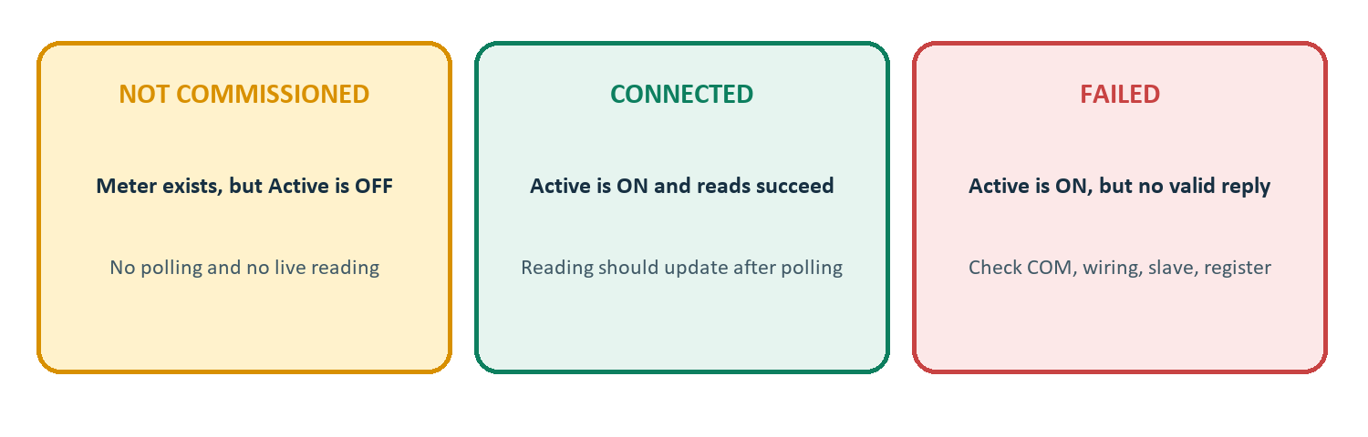

Commission one meter at a time
Activate the first meter, verify a sensible changing value, then continue with the remaining channels. This makes wiring or register errors much easier to isolate.

8. Verify the meter in the application
1. Wait for polling — Allow at least the configured interval—normally about 5 seconds.
2. Check Dashboard — Confirm the meter appears, the source badge is correct, and status becomes Connected.
3. Check the source page — UMEME meters must appear only on UMEME; Generator meters only on Generator.
4. Open View meter — Confirm the live accumulated reading, timestamp and day/month/year charts.
5. Prove the value moves — Change the DDC test value or observe real consumption. A fixed number can be a valid stable load, but it must respond to a controlled test before sign-off.

Example live status
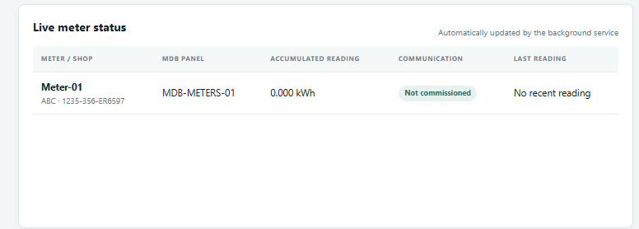
Figure 2. “Not commissioned” means the meter has not been activated; it is not a wiring diagnosis.

Status decision
Status | Check first
Not commissioned | Edit meter → turn Active ON → save
Failed | Controller test, Windows COM, A/B, slave and register
Connected, wrong value | Register base, data type, word order and scale
Connected, stale value | DDC logic/source value and timestamp/polling

9. Finish billing readiness
A connected meter is not yet fully ready for billing. Complete the commercial settings before creating the first invoice.

Tariff
1. Open Operations — Go to Meter-specific tariff history.
2. Select the meter — Tariffs are independent; Shop 1 and Shop 2 can have different prices.
3. Enter price and currency — Choose the correct ISO currency, such as UGX or USD.
4. Set effective date/time — This is when the tariff begins. It is not the invoice publication date.
5. Confirm tariff — Review the history so the correct rate applies to the intended billing period.

Invoice period
Use Billing operations to select the individual shop/meter and the flexible period start and end dates. Review the opening/closing readings and consumption before finalizing. Generate draft invoices first; finalize only after verification.
First-live-invoice control
Before invoice 1, record the commissioning reading and time, verify the shop and tariff, and make a backup. Never bill test readings that were written during commissioning.

Backup
• ☐ Create a backup after all controllers, meters, users and tariffs are verified.
• ☐ Store a second copy outside the PC.
• ☐ Label the backup with site name, date and software version.
• ☐ Test restore on a non-production system when practical.

10. Troubleshooting reference
Symptom | Most likely cause | Corrective action
Not commissioned | Meter Active is OFF | Edit meter, activate and save
Controller TX flickers; no RX | No DDC reply | Check A/B, slave, frame and termination
COM port cannot open | Wrong/changed port or another app owns it | Check Device Manager; close competing app
All meters on one DDC fail | Controller/bus problem | Run controller test before meter checks
Only one meter fails | Register/channel mapping issue | Check its address, type, order and scale
Huge or impossible value | Wrong word order/data type | Try approved UInt32 order; verify source words
Value is ×100 or ÷100 | Wrong scaling factor | Confirm DDC engineering units and scale
Meter absent from Dashboard | Inactive, unassigned, or filter/source mismatch | Activate; confirm shop and source
Wrong UMEME/Generator page | Incorrect Power source | Edit meter and save correct source
Works until reboot | Service/driver/COM assignment issue | Set service startup; keep adapter in same USB port

Escalation evidence to collect
• ☐ Screenshot of Device Manager COM port.
• ☐ Controller settings page and exact test result.
• ☐ DDC protocol/slave/serial settings.
• ☐ Register map and one known raw value.
• ☐ RS-485 wiring/termination photo.
• ☐ Meter Edit screen showing Active, source and register.

11. Commissioning record and final sign-off
Complete one record for every controller. Keep it with the site handover documents.
Field | Site value
Site / panel
Controller name
DDC physical port
Windows COM port
Protocol / serial frame | Modbus RTU / 9600 / 8E1
Slave address
First register / stride
Data type / word order / scale
Number of active meters
Technician / date

Final checklist
• ☐ Controller test receives a valid Modbus response.
• ☐ Every live meter has its real name and serial number.
• ☐ Every live meter is assigned to the correct shop/location.
• ☐ Every live meter is assigned to UMEME or Generator.
• ☐ Every live meter has the confirmed register, format and scale.
• ☐ Every live meter has Active ON—none remain Not commissioned.
• ☐ Every meter shows Connected and a sensible changing reading.
• ☐ Tariff, currency and effective date are correct for each meter.
• ☐ Test readings are excluded from the first invoice period.
• ☐ A verified backup has been created and stored safely.
READY FOR LIVE OPERATION
Sign off only when every checkbox above is complete. If a meter says Not commissioned, return to its Edit page and activate it before leaving site.

